SY486J: Cyber Crime Investigation: Lab Four
Acquisition in Windows

This is what we have done so far (from previous lab):
- Sanitized the target drive
- Prepared out evidence drive (suspect drive)
Please follow the steps provided in the previous lab to acquire the suspect drive in the Linux.

The goals of this lab are to:
- To expose to the proper way to acquire a forensic image of a suspect drive using a hardware blocker and FTK imager.
- To acquire/capture the RAM using DumpIt and FTK imager.

Please read the below steps carefully:

- To run FTK Imager, you need to install Visual C++, download vcredist_x64 from the Share and run it on your computer.
- Download and install FTK Imager from the Share drive.
- FTK requires a minimum of 1.9GB to create an image, we therefore need to create a 10G size partition on our C drive, wipe it and format it using FTK in order to store the image created by FTK. For the partitioning, we will use a tool available on the share called pw11-exe in Step 1. The partition is the target drive for your FTK imaging.
- Follow the FTK imaging instructions in Step 2.

Step 1: Creating a partition on drive C: to store the FTK image

- Download and install pw11-free.exe
- Right click on the C drive and select “split” on the pop up menu.
- Create a partition that is 10GB using the adjusting arrows.
- Select the newly created partition and select “wipe” on the pop-up menu.
- Select the newly created partition and select “format” on the pop-up menu
- Click apply at the top left corner of the tool.
- Click restart for the changes to be effected.
- Go to “This PC” and look out for the newly created drive. Please show it to Dr.Shumba. The created drive will be the target for your image.

Step 2: Acquisition using FTK Imager

At this point, please connect the suspect to the write-blocker and start the imaging process.

- Launch FTK Imager by clicking on the ‘AccessData FTK Imager’ icon. The following screen will appear once the program has been launched.

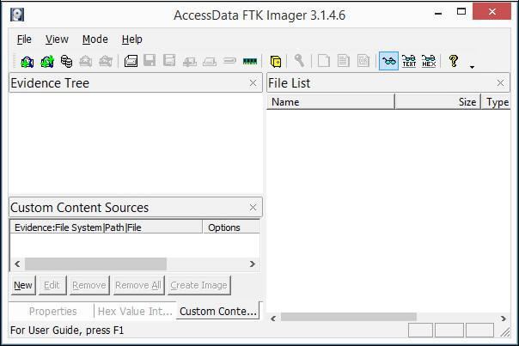

\
- Click File and look over the various options for creating images. We will be using the ‘Create Disk Image’ option. It is good to note that you can also capture from memory, and image individual items.

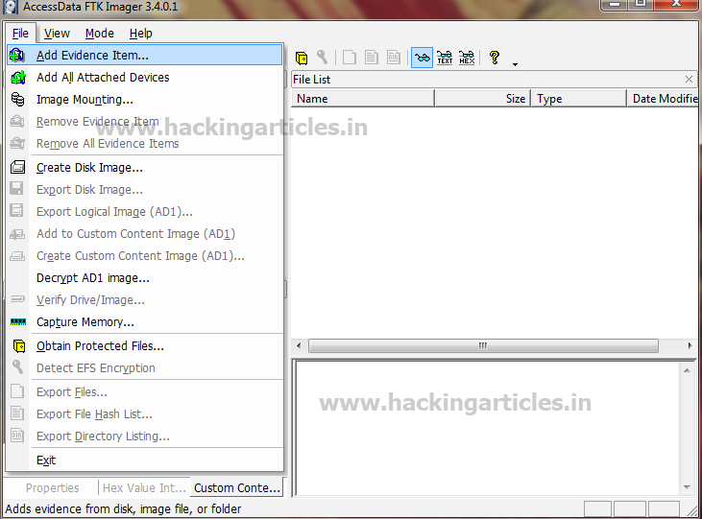

- Click ‘Create Disk Image’. The following window will appear. Select the correct drive type for the situation. Select physical drive and click Next.

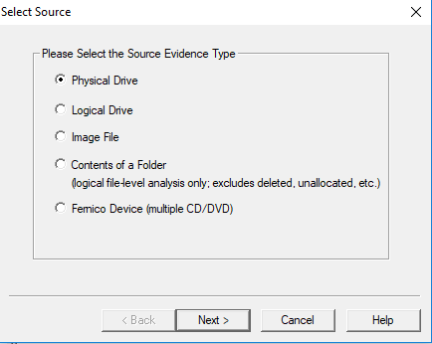

- Select the suspect drive in the resulting ‘Select Drive’ window. This should be your evidence drive (suspect drive). Click Finish.

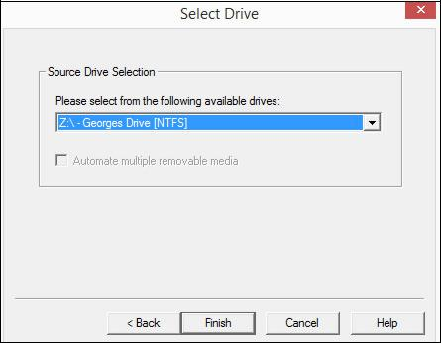

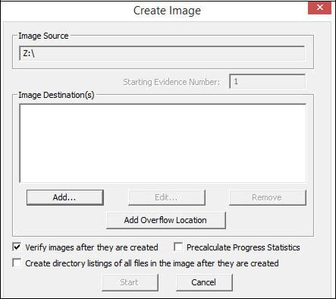
- The following ‘Create Image’ window will appear. Note that the appropriate Image Source has been selected. Click Add to select the image type and choose the Image Destinatiin
- We will be using dd. dd (disk dump) is the raw image file format. It is used not only in Windows, but also in Linux. Select ‘Raw (dd)’ and click Next.

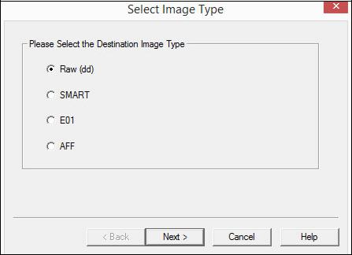

- The following window will give you the opportunity to enter information about the case for the image. This is useful for organizational purposes. Since keeping track of everything and having detailed notes is pivotal, it is helpful to enter this information. Click Next.

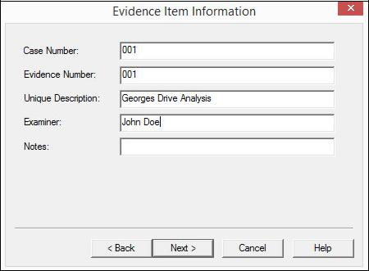

- Select the folder in which the image file will be placed (should be you’re newly created partition – you can create a folder on the drive). Also, give the image file a specific name if desired.

- The ‘Image Fragment Size’ field specifies the number of megabytes into which FTK Imager should split each chunk of the image file; this can be helpful if the image is very large or will be transported. If a value is entered in this field larger than the size of the data to be imaged, only one file will be created and it will be the size of the data. For our tutorial, if the default value of 1500 MB is left, FTK Imager will create one 1GB file since the drive we are imaging is only 1GB.

The second option deals with compression; dd images cannot be compressed, but some proprietary formats, like .e01, can. Click Finish.
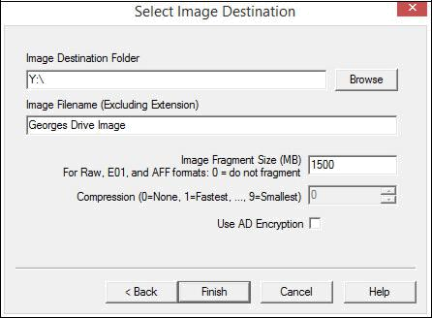

- The disk image will be saved to your new partition. Note also that the disk image will be created in raw/dd. Make sure that ‘Verify images after they are created’ is checked – this will automatically create a hash for the image. The hash is used to verify that no changes have been made to the image file. More information about hashing may be found in the hashing tutorial. Click Start to create the image file.
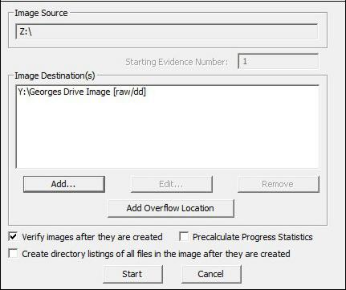
- The image will now be created. This may take some time depending on the file size.
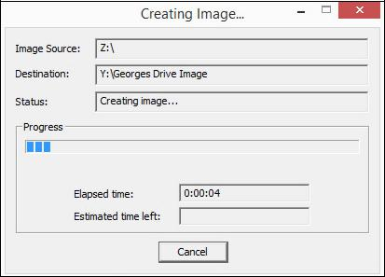

- The following window will appear once the image has been completed. Note that both an MD5 and SHA1 hash have been created and verified. The hash is the fingerprint of the disk image – if the disk image is altered, the hash values will change. Keeping track of these hashes will allow you to continually verify the hash of the image file during your investigative process. Any other investigator should be able to replicate this hash; this maintains integrity in the eyes of the court.
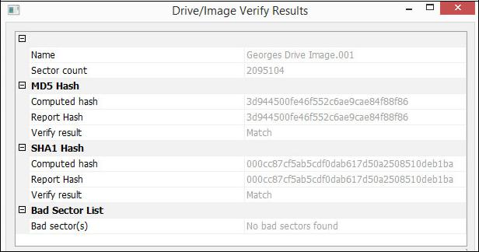

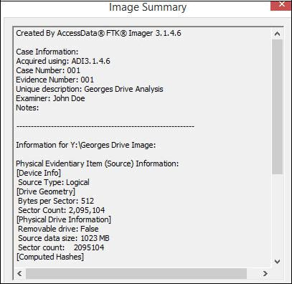
- Click on ‘Image Summary’ to view the following results pertaining to the image that has just been created. This information should verify what was entered in the creation process. It will also verify the created hashes. Also, for your reference, this information has been printed out into a text file in the location to which the image file was saved.

At this point, the disk image has been created. This is essential for analyzing the contents without touching the original drive. In a following tutorial we will cover viewing the contents of this disk image file. The disk image is completely intact and untouched at this point. It is imperative that the hashes be recorded and kept for reference, as they must be rechecked during the course of your investigation. Additionally, it is imperative that a form of write blocking be put in place to prevent changes to the disk image. Write blocking is covered in a following tutorial.

Show Dr. Shumba the created image

RAM Acquisition

RAM Capture Tools
- FTK Imager – Windows based program capable of capturing local drives and local RAM.
- Win64dd/MWMT DumpIt – A program that can be installed on any Windows machine in order to capture/dump local RAM from that computer. This is oftentimes a tool of choice for triage forensics.
Use of FTK to capture the RAM
For this, we need to run the FTK Imager from a USB. Follow the directions below
- Create a folder on your created partition and call it RAM_Images.
- Create a sub folder called Windows_RAM_FTK, and Windows_RAM_DUMP
- Perform a few tasks in the Windows VM, these may include:
- Open Notepad and type in your own email address and leave it open
- run the command line,
- run netstat and leave it running
- run ipconfig
- Add two users by typing the following at the command line

net user waldo Apple123 /add
net user YOUR-NAME SuperSecret! /add

- Start FTK Imager. From the menu click File, Capture Memory.
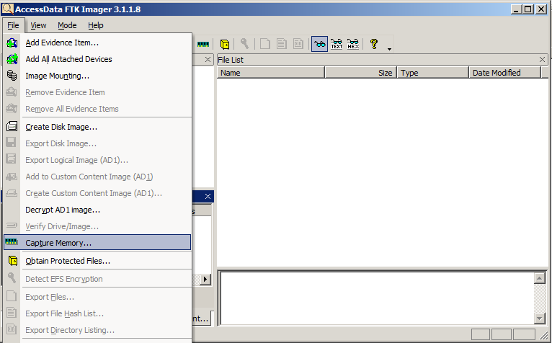

- In the "Memory Capture" box, click the Browse button. Click Desktop and click OK.

- In the "Memory Capture" box, click the "Capture Memory" button.

- You should see a box saying "Memory capture finished successfully", as shown below:

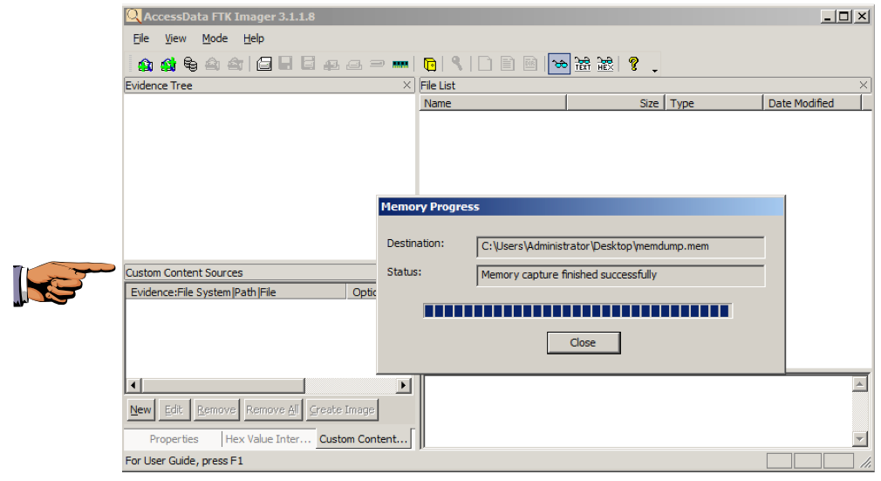

Move the memory dump file to your Images folder. Clearly label the folder – Windows_RAM_FTK

Use of DumpIt to capture the RAM

- Download and extract Comae-Toolkit zip from the share.
- Go to the extracted files and run DumpIt.exe
- The RAM image is stored in the folder where the images were extracted.
- Move the .dmp and the .json file to the Windows_RAM_DUMP
- Please show Dr.Shumba the files.

